**Connecting BMP280 Barometer to Raspberry Pi**

1. Wire BMP280 module to Raspbery Pi as shown in *Figure 1.*
2. Run the following commands to install pertinent libraries:
   * sudo apt-get install -y python-smbus
   * sudo apt-get install -y i2c-tools
3. Reboot the Raspberry Pi.
   * sudo reboot
4. Run the raspi-config tool.
   * sudo raspi-config
5. Use the **arrow keys** to go down and select “**3 Interface Options**“. Once this option has been selected, you can press **Enter**.
6. Next, use the **arrow keys** again to select “**P5 I2C**“, and press **Enter** once highlighted to select this option.
7. The following prompt will appear: “**Would you like the ARM I2C interface to be enabled?”** Select **Yes** and press **Enter** to proceed. Select **Yes** and press **Enter** for any prompts that follow this, and press **ESC** to proceed in the terminal.
8. Next, run the following command:
   * sudo i2cdetect –y 1

The output should look like *Figure 2*.

1. Use the number that appears in the output as the address on **line 107** in **31_bmp280.py**. The line should look like the following:
   * def __init__(self, bus_number=None, **address=0x76**):
2. Run the following commands to test the hardware.
   * cd <git-repo-path>/Barometer\ Module/BMP280_Code/BMP280/Raspberry\ Pi\ Code/
   * python2 31_bmp280.py

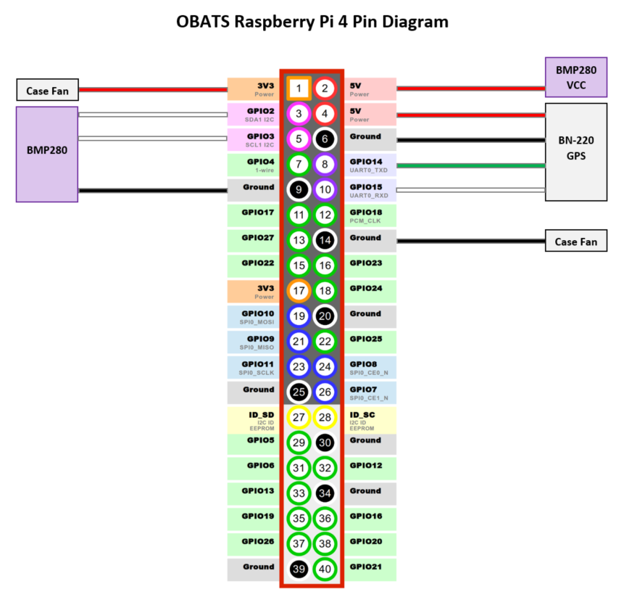  
Figure 1: Raspberry Pi – Barometer wiring diagram

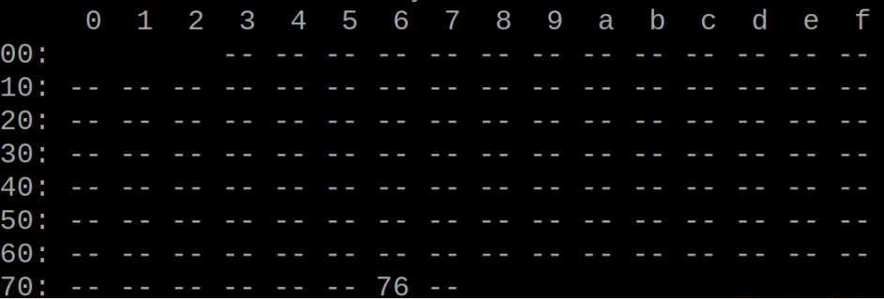

Figure 2: Output of i2cdetect